**Project Planning Phase**

**SPRINT DELIVERY - 4**

|  |  |
| --- | --- |
| Team ID | PNT2022TMID24776 |
| Project Name | Project – Smart Farmer-IoT based Smart Farming Application |
| Maximum Marks | 8 Marks |

**Web UI:**

To make the user to interact with software.

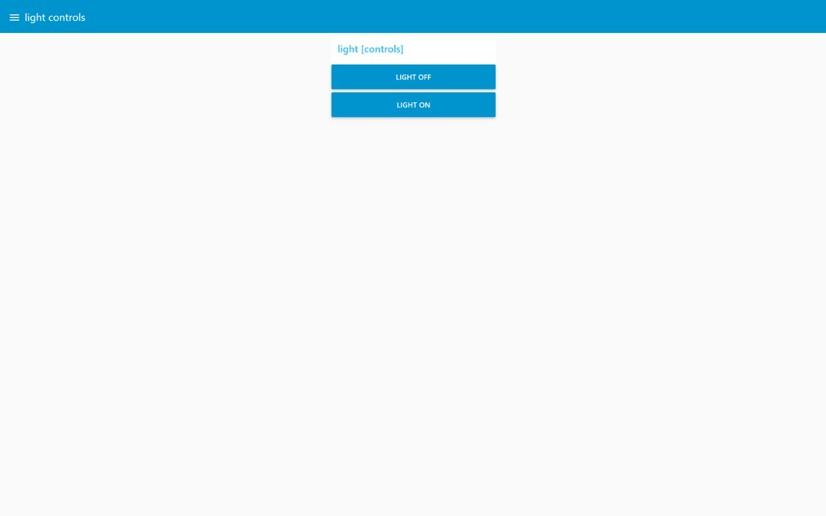

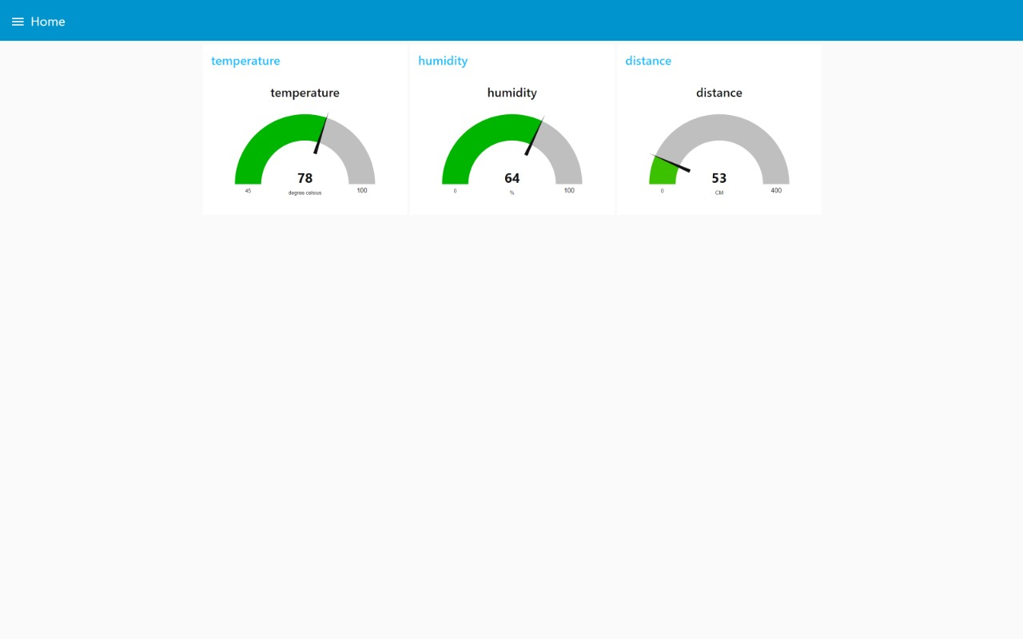

**Explanation:**

* The output of the node red application can be viewed from the
* That Application runs through the python code which is connected with IBM IoT Watson Platform.
* In the UI we can view Live result and when we click on the Motor ON and OFF button.
* It will generate a message and get runs in the Python code and displayed in Python script (which is given above for example)

